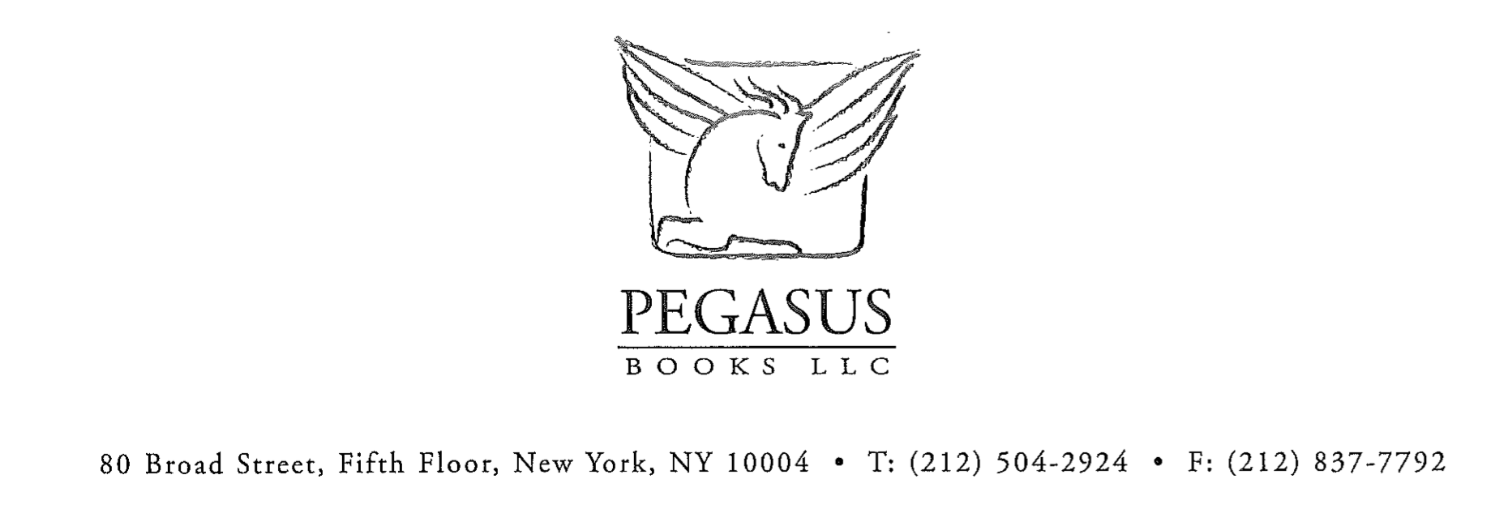
FOR IMMEDIATE RELEASE

The Woman Who Could Not Forget
Iris Chang Before And Beyond The Rape of Nanking

A memoir by Ying-Ying Chang

Introduction by Richard Rhodes

A moving, illuminating memoir about the life of world-famous author and historian, Iris Chang, as told by her mother.

Iris Chang’s best-selling book, The Rape of Nanking, forever changed the way we view the Second World War in Asia. It all began with a photo of a river choked with the bodies of hundreds of Chinese civilians that shook Iris to her core. Who were these people? Why had this happened and how could their story have been lost to history? She could not shake that image from her head. She could not forget what she had seen.
A few years later, Chang revealed this “second Holocaust” to the world. The Japanese atrocities against the people of Nanking were so extreme that a Nazi party leader based in China actually petitioned Hitler to ask the Japanese government to stop the massacre. But who was this woman that single-handedly swept away years of silence, secrecy, and shame?
Her mother, Ying-Ying, provides an enlightened and nuanced look at her daughter, from Iris’ home-made childhood newspaper, to her early years as a journalist and later, as a promising young historian, her struggles with her son’s autism and her tragic suicide. The Woman Who Could Not Forget cements Iris’ legacy as one of the most extraordinary minds of her generation and reveals the depth and beauty of the bond between a mother and daughter.

“In this brave memoir you will share in the celebration of a life, allowing us to experience her presence again. Full of courage and conviction, full of life.” –Richard Rhodes

Ying-Ying Chang is the mother of Iris Chang. She has a Ph.D. from Harvard in biochemistry and was a research associate professor in biochemistry at the University of Illinois in Urbana-Champaign with her husband, Shau-Jin, a physics professor. She lives in San Jose, California and is on the board of the Iris Chang Memorial fund, irischangmemorialfund.net.

$29.95 • 448 pages • Hardcover • 978-1-60598-172-7 • Biography

May 15th, 2011

